Read Me File – Group 5.3
Meetly Description
Meetly is our intelligent scheduling application that helps friend groups find the best time and event to meet by combining user preferences, calendar availability (via Google Calendar) and a machine learning recommendation engine.

How to deploy the app:
Install requirements with: pip install -r requirements.txt
Now you can run it with: streamlit run app.py

Important note regarding Authentication:
You may notice a difference between our demo video and the current behavior of the application. In the video, the user manually logs in via Google. In this submitted version, the app connects automatically.
We changed this because due to strict Google Cloud security measures (Geoblocking and "Anti-Abuse" systems), logging into our test account from new locations often triggers complex 2-Factor-Authentication challenges that are difficult to resolve remotely.
Therefore to ensure a seamless assessment experience for you, we have implemented an Auto-Login Token:
- When you launch the app, you are instantly connected to our Google Account (csprojekt2025@gmail.com).
- You do not need to enter a password or 2FA code.
- The full functionality (Calendar API, Recommender) works immediately using our pre-filled test data. All you have to do is add profiles as indicated below.

However, if you want to disable the Auto-Login and try to connect to Google either way, all you would have to do is:
- Delete the section [demo_mode] and its content in the file secrets.toml and restart the app.

You should see the „Connect to Google Calendar“ button. However, trying to connect, will probably lead to the already described problem.

How to use the app:
To use the app, we created a Google Account where we merged all our personal calendars. That's how we ensured, that all our calendars are combined. This is the calendar we then integrated through an API into our App. In order to test the app from our point of view, you would have to log in through the main Google Account as following, when asked to “Connect with Google Calendar”:
username: csprojekt2025@gmail.com
password: QWERTZ45KarTr
As already mentioned Google sometimes requires 2FA. If this is the case, please try to use one of the following Backup Codes:
0251 5713
4976 2628
9726 8206
0352 6073
4830 9030
0361 9284
2510 9834
7487 5570

There is a risk that this login will still fail. Just like with the app authentication, Google's security systems might detect your login attempt as "unusual activity" due to the location change (Geoblocking).
Recommendation: If you encounter security blocks while trying to upload your own calendar, we recommend sticking to the already connected profiles (mentioned below) to evaluate the app's functionality. These profiles are already fully integrated and require no further setup.

Creating a profile:
Using Existing Profiles (recommended): To test the app immediately, you can select the users that are already linked to the Google Calendar:
Natascha, Mia, Ladina, Michelle, Sina

If you were sucessful in connecting your own calender to our shared one you can also create your own profile.
Please make sure that you chose a profile name, that is also part of the name your calendar is given by default when you add it to our shared google calendar. For example:
Name the calendar is given when integrating it into the shared calendar: laura.müller@gmail.com
Names you can give your profile: Laura, Müller, gmail, com, aura, ler, …
The email field: serves as a unique ID. You don't necessarily need a real email address, but you must remember what you typed to edit your preferences or name later.

Description of the individual files:
App.py:
This is our main entry point for the Streamlit application.
Key components:
- Core application setup
- Database initialization
- Management of the session state
- Page navigation controlling based on user selections
Auth.py:
This file generally contains the logic necessary to authenticate the application with Google Calendar API using the OAuth 2.0 flow. It is critical to securely obtain the user's permission to read their calendar data. The function manages credentials, handles redirection to Google's login page, processes the callback (code exchange) and creates the usable API service object.
In the submitted test version of the App, we made some changes to the authorization process. These changes allow Auto-Login if the Demo Token is present in the secrets.toml file. If the Demo Token is removed, the authorization process works normally, requiring login into our Google Account. The newly added code is closer described as following:
Two new imports were required:
- Import json: required to parse the token_json string (which is formatted as JSON) from the Streamlit secrets into a usable Python dictionary object.
- from google.oauth2.credentials import Credentials: This is used to instantiate a valid Google credentials object directly from the authorized user information (the data loaded from the parsed token dictionary), effectively skipping the need for the browser-based OAuth login flow.
The change involves the introduction of logic to check for a pre-saved Demo Token within the application's secure secrets. By loading and parsing this token, the application can now immediately create a valid Google credentials object. This completely bypasses the standard multi-step OAuth process, allowing the app to serve as an instant demo or test environment.
Additionally, the code now implements a Dynamic Redirect URI which automatically switches the application's return URL between the localhost address (for development) and the deployed Streamlit URL (for production). This ensures that the Google authentication process never fails due to a mismatched URL, significantly improving stability across different environments.

Database.py:
This file handles everything related to storing and managing the application's core data using SQLite.
Key components:
- Schema initialization: Creating the necessary users and saved events tables.
- User management: Handling the creation, retrieval and updating of user profiles and their preference keywords.
- Event persistence: Storing finalized, recommended events selected by the group, along with their detailed metadata (e.g., match score, attendees) for display on a calendar view.
- Data integrity: Ensuring unique user records (via email) and preventing duplicate event entries.
Events.xlsx:
This file serves as the data base for the recommender. It is a data base with all the events, that can be proposed by the recommender according to the user’s preferences.
Google_service.py:
This file contains the fetch_and_map_events function, which connects to the google calendar to retrieve all scheduled events for a defined period and maps these events to specific users to create an availability map.
Recommender.py:
This file contains the core recommendation engine logic for Meetly. It processes local activity data and combines it with user availability (fetched from Google Calendar) and user interest profiles (from the database) to calculate a weighted score for each potential group event.
Key components:
- Data loading: Reads activity ideas from static files (events.xlsx)
- Interest matching: Calculates how well an activity's category matches the selected group member's preferences.
- Availability check: Calculates the number of people available for a given time slot by cross-referencing against the Google Calendar busy map.
- Scoring and ranking: Combines interest and availability scores to rank the best potential time slots and activities for the entire group
Machine Learning logic and explanation:
We implemented a "Content-Based Recommender" algorithm.
How it works:
- Feature Engineering: We combine the Title, Category, and Description of an event into a single text vector.
- TF-IDF Vectorization: We convert this text into mathematical vectors using TF-IDF (Term Frequency-Inverse Document Frequency).
- This gives more weight to rare, specific words (like "Football") and less to common filler words.
- Cosine Similarity: We calculate the angle (similarity) between the group's interest vector and the event's vector.
- A value of 1.0 means a perfect match, 0.0 means no similarity.
Requirements.txt:
This file contains all the external packages we used in our code for the application.
Views.py:
This file acts as the presentation layer for the Streamlit application. It contains all the functions responsible for generating the user interface (UI) for the different pages in the application's sidebar navigation.
Key components:
- Managing page structure (Start, Profiles, Planner, Calendar)
- Handling user input via Streamlit widgets (form, buttons, date pickers)
- Orchestrating data flow by calling logic functions from the 'auth', 'database', 'google service', 'recommender' and 'visualization' files to display results.
- Rendering complex components like the interactive calendar and event cards
Visualization.py:
This file is responsible for the visualization part in our app. It takes the data from our Calendar and then displays it in a graphic.
Key components of this file:
- Data transformation: Converts raw event lists into clean pandas df
- Data aggregation: Calculates event counts per person and per day of the week
- Visualization: Generates interactive charts (using Matplotlib/Seaborn within Streamlit)
- UI Integration: Provides the Streamlit interface for filtering data by date range and toggling between different chart types

Secrets.toml:
The secrets.toml file is the security and configuration hub for accessing the Google Calendar API. It securely stores the Client Id and the Client Secret, which are the credentials that identify your application to Google. This file is crucial for initiating the secure OAuth flow used to authenticate users and obtain calendar data.
Secret.toml file add on:
For the submitted testing version we added a demo token to the secret file which allows a quick start of the application without having to actively log into our Google Account. This allows to test the full functionality of the app. Through this, the application serves as a demo so one can easily test the app and its features.
Our Contribution Matrix
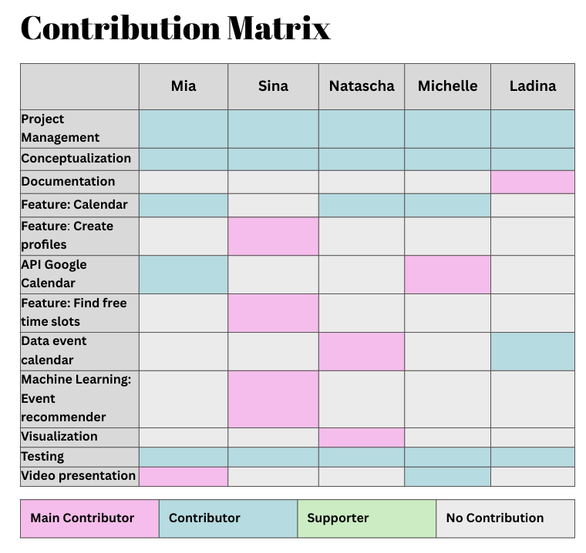

References and Attribution
This project relies on the following libraries and external resources:
- Streamlit: For creating the web application interface.
  - Official Documentation
- Google Calendar API: For fetching user availability data.
  - API Documentation
  - Python Quickstart Guide (for OAuth Flow)
- Scikit-learn (TF-IDF): Used within the recommendation engine for calculating semantic interest scores.
  - TF-IDF Vectorizer Documentation
- SQLite: The lightweight database used for local storage of user profiles and finalized events.
  - Python sqlite3 Module Documentation
- ChatGPT: Used for creating code, handling errors and structuring our app.
  - https://chat.openai.com/
- Gemini: Used for creating code, handling errors and structuring our app.
  - https://gemini.google.com/

